EXPERIMENT 2
- Alter the table STUDENT2 with following structure.

# | Column Name | Constraints
1 | RegNo | PRIMARY KEY

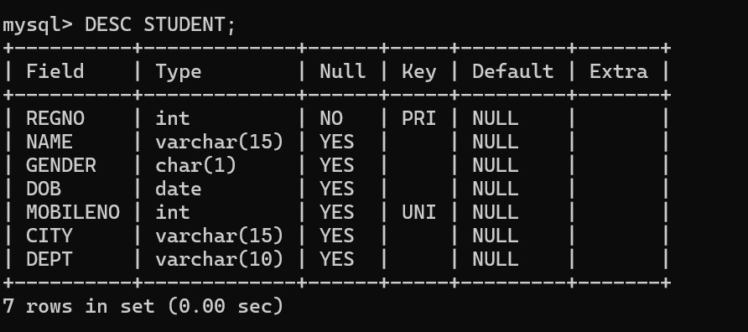

2)Alter the table name FACULTY with following structure.

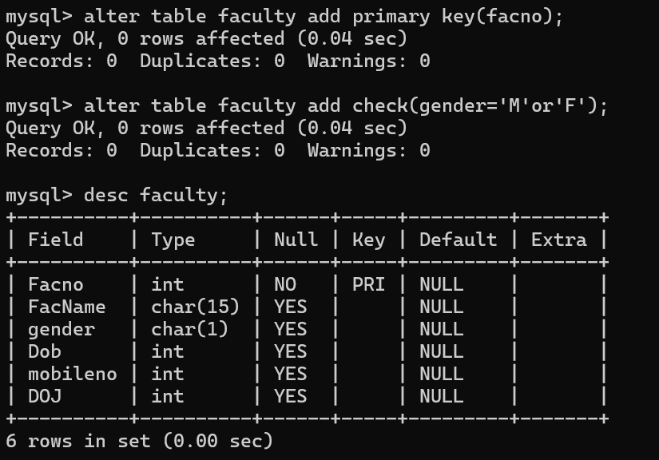
3) Alter the table name DEPARTMENT with following structure.

# | Column Name | Constraints
1 | DeptNo | PRIMARY KEY

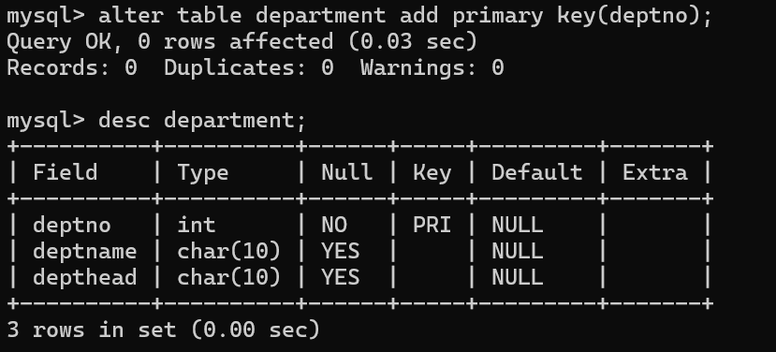
4)Alter the table name COURSE with following structure.

# | Column Name | Constraints
1 | CourseNo | PRIMARY KEY
2 | SemNo | 1 to 6

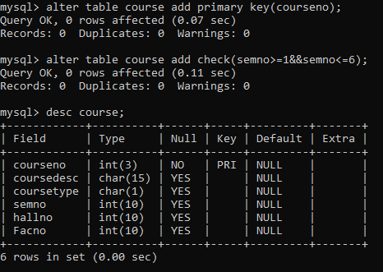
5)Alter the table name STUDENT2 with following structure.

# | Column Name | Constraints
1 | S1Name | UNIQUE KEY

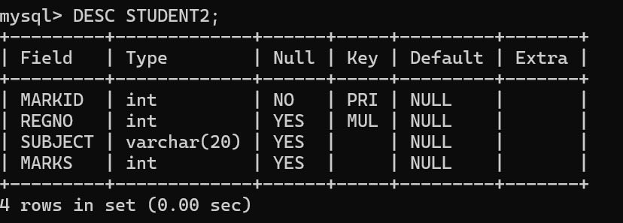
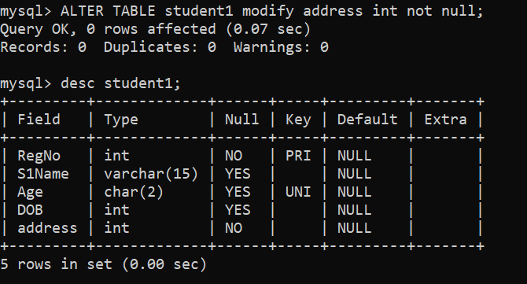
- After the STUDENT2 & STUDENT3 tables are successfully created, test if you can add a constraint FOREIGN KEY to the RegNo of this table.

